Waves- Guided Notes
Name: _________________________________________ Date: ____________ Core: _____
- A wave is any type of _____________________ that carries ___________________.
  - It may MOVE matter, but does not ____________________ it.
  - Waves are moving ____________________.
- Waves are created when a __________________ (force) creates a _____________________.
  - Vibrations in materials set up ___________________ ___________________ that spread AWAY from the source.
- Wave behavior can be described in the following ways:
  - How fast the _____________________ spreads
  - ________________________ - the distance between successive peaks of the disturbance
  - Waves move at _____________________ speeds in __________________ materials.
- There are two main types of waves:
  - _______________________ - waves that can travel through empty space (a vacuum)
    - They do not require a _____________________ to travel
  - _______________________ - waves that must have matter (medium) to travel through.
    - Examples: sound, ________________________ (seismic waves)
- Mechanical waves
  - Must have a ___________________, such as a solid, liquid, or gas, to travel through.
  - Some examples are:

- Mechanical waves: 2 types
  - Longitudinal waves: the motion of the medium is ___________________ to the motion of the wave
  - ________________________ are longitudinal
  - The energy is being carried by the wave ____________ and ______________.
  - The energy and the matter are moving in the __________________ direction.
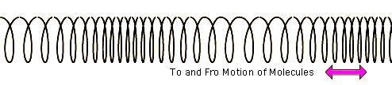
  - __________________ is when waves are close together.
  - __________________ is when waves are far apart.
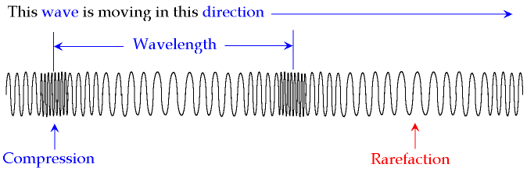
- Transverse Waves: the motion of the medium is ____________________ to the motion of the wave.
  - The waves move _________ and ________.
  - The __________________ and _______________ are NOT moving the same direction.
  - The energy and matter move at a _________________ angle.
  - ________________ are transverse.
- Label the parts of the wave: (wave crest, wave length, wave height, amplitude, trough) 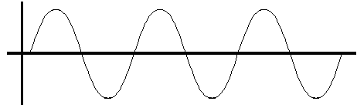
- Transverse wave parts:
  - Crest: the ___________________ point of a wave
  - ____________________: the volume (or height) of a wave.
    - As weight height _______________, volume _______________.
    - Volume is measured in ____________________.
  - Trough: the __________________ point of a wave.
  - ________________: the pitch, or “high” or “low” length of a wave
    - As ____________________ increases, pitch ___________________.
    - Measured in __________________.

