Waves: Day 5 Name: __________________________ Core: _____ Date: Monday, March 27th
- The matter in a transverse wave travels: A) In circles B) Back & Forth C) Up & Down
Learning Check
- Sound is an example of which type of wave? A) Longitudinal B) Transverse C) EM
- T/F: S Waves are longitudinal: A) True B) False
Transverse Wave * Medium *
Electromagnetic Wave * Radio Wave
Infra-red * Microwaves * Vacuum
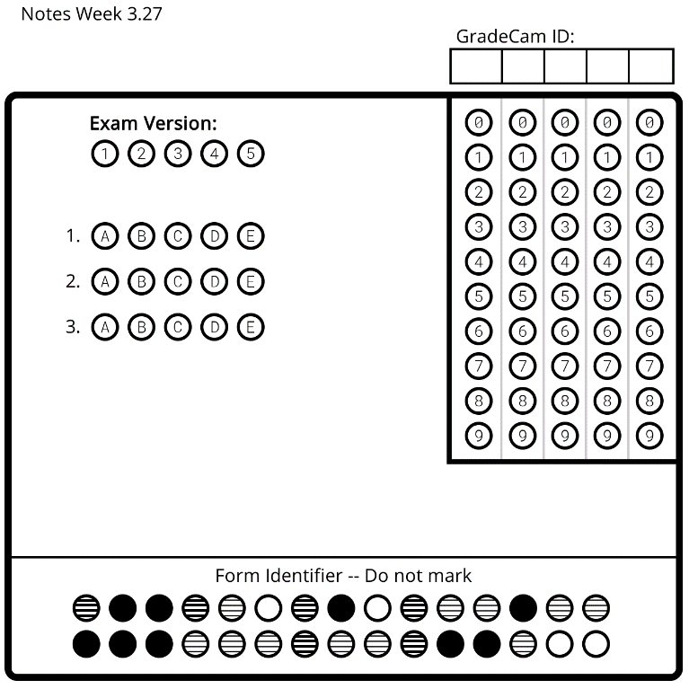
Vocabulary

1. _________________ this is the absence of matter; space.
2. _________________ these waves don’t require a medium to travel. An example is visible light.
3. _________________ these waves are caused by thermal energy and are invisible to us unless we use special equipment.
4. _________________ these waves move up and down.
5. _________________ the matter a wave travels through
6. _________________ these are on the EM spectrum and have the longest wavelength.
7. _________________ these are just radio waves with very short wavelengths.
* NOTES *

- All electromagnetic waves have the following properties:
  - They can travel through a ___________.
  - They all travel at the same _______________ in a vacuum: 3.00 x 10⁸ m/s. (EM waves don’t travel this fast in other _______________. )
  - They are ___________________ waves.
  - They are produced when ____________ or electrons lose energy.
- Radio Waves:
  - Have the longest _________________. They are used to carry radio and _________ signals.
  - Waves with wavelengths larger than 10m can be transmitted around the earth by _________________ off of the upper ________________ (the ionosphere).
  - Wavelengths shorter than 10m pass through the ionosphere. Since they cannot be reflected off of the atmosphere, these “____________ ___________” need to travel to several ___________________ that are all in “line of sight” of each other.
  - Radio waves are not dangerous, as they carry very small amounts of _______________.
  - Uses [give 2 examples listed]: ________________________________________________________________________
- Microwaves:
  - Microwaves are just very short wavelength ______________ waves.
  - They are absorbed by some substances such as __________ (this is why your food warms up in a microwave oven). They pass through glass, china, paper and plastic but are ______________________ by metals.
  - Mobile phones are portable ___________________ transmitters and receivers that communicate with the nearest base station.
  - As microwaves pass through the _____________________, they can be used to send signals up to a satellite which then relays them around the world.
  - Uses [give 2 examples listed]: ____________________________________________________________
Activities!
A) [I need a review.] Come up to the board and watch parts 1, 7 & 8. Then, on the back of this paper, draw the wave along with an example of how the wave is used.
B) [I’m ready to practice.] Grab the coloring sheet from the front desk. In the wavestown picture, circle and label all examples of radio & microwaves. Then, color the picture.
C) [I’m ready for a challenge.] In a 5-frame comic strip, explain either how music is transferred to a radio from a radio station OR how your friend’s voice is transmitted to your cell phone.

