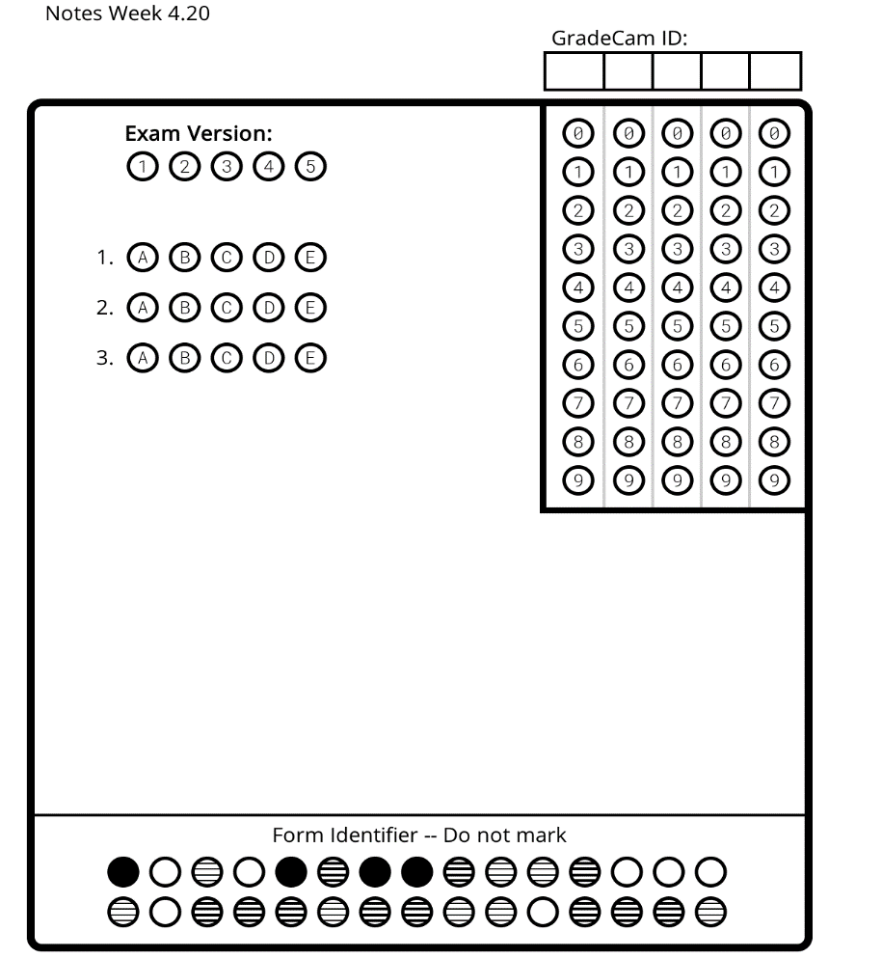
Waves: Day 13 Name: ________________________ Core: _____ Date: __Friday, April 21st ____
1. The type of energy that we can hear:
A) Light Waves B) Sound Waves C) Radio Waves
2. The distance between adjacent compressions:
A) Wave Height B) Amplitude C) Wavelength
3. As the ______ of a wave increases, so does the energy:
A) Amplitude B) Line of Origin C) Crest

Draw It: A sound wave in…
Solid:

Liquid:

Gas:

Sound Travels Through Matter
- ________________ is a kind of energy that can be heard.  - A sound is made when things ______________.  - Sound travels in ________________.  - Sound must travel through _____________ (a medium) to be heard.  - The vibrating object makes the matter around it ___________________, too.  - Sound vibrations move through the air into your ears and make your _________________ vibrate.  - _______________ is how loud or soft a sound is - _______________________.  - ________________ is how high or low a sound is- ________________________. | Solids:  - Some sounds that we hear travel through _________________.  - Sound waves travel very ____________ through solids.  - For Example: if you put your ear against the _______________ and someone hits the desk, the sound wave travels to your ear through the ________________ - your desk. | Liquids:  - Some _______________ that travel through water.  - Sound waves travel __________________ through water than through ______________.  - ________________ is the way to use sound to locate objects under water.  - What animals use sonar?  _____________________ _____________________ | Gases:  - Most of the _______________ we hear travel through ______________, such as air.  - Sound waves travel _________________ through the air.  - For example: Sound from a ________________, a horn, or an alarm clock travels through the air.
- [I need a review.] BrainPop Video: Sound. With a small group, watch the BrainPop Video: sound, then each person will complete the activity sheet.
- [I’m ready to practice.] Sound Art: Draw a scene with sound interactions labeled within. Include sound waves in solids, liquids, and gases.
- [I’m ready for a challenge.] BrainPop Timeline: Sound- Time Zone X. Draw a timeline with at least 5 boxes and fill in as you complete the timeline. Include: Who? What? When?

