Waves: Day 12 Name: ____________________ Core: ____ Date: __Thursday, April 20th___
1. What is the purpose of the retina?  A) It uses rod cells to detect black, white, and shades of grey and cone cells to detect color light.  B) It forms the images that we see.  C) It bends, or refracts, light onto the back of the eye. | 2. The wavelength of a transverse wave is the distance:  A) Between successive crests or troughs.  B) from the top (crest) of the wave to the bottom (trough) of the wave  C) from the beginning to end of the wave | 3. As the amplitude of a wave increases, what also increases?  A) the wavelength  B) The distance between successive crests or troughs  C) the amount of energy the wave carries
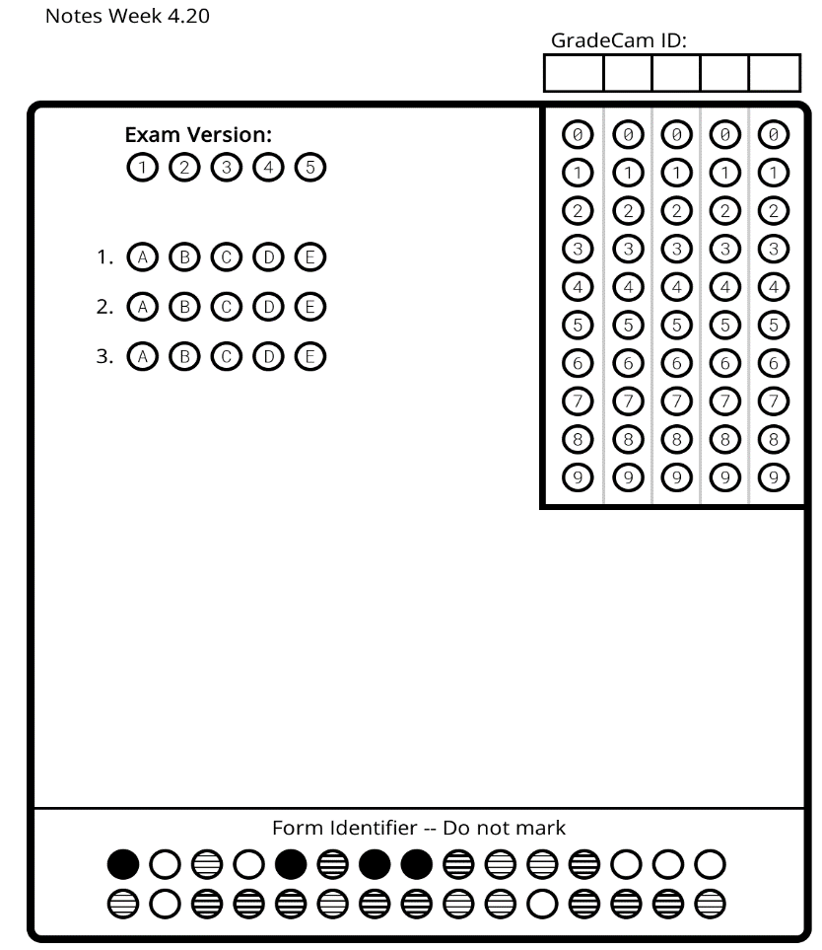
Vocabulary

1) A form of energy that we can hear, caused by a vibration.
2) Any disturbance that carries energy.
3) The matter (solid, liquid, or gas) that a wave travels through.
4) The part of a longitudinal waves where the atoms are very close together.
5) The part of a longitudinal wave where the atoms are very far apart.
6) The distance between compressions of a longitudinal wave.
1. ______________

2. ______________

3. ______________

4. ______________

5. ______________

6. ______________
Medium * Compression * Wave
Rarefaction * Sound * Wavelength

N O T E S

- What is sound?
  - Sound is a form of _____________ that can be ____________ and travels in ______________ waves.
  - When matter ______________, or moves back and forth very quickly, a ________________ is made.
  - Sound waves can ONLY travel through a __________________: solids, liquids, or gases.
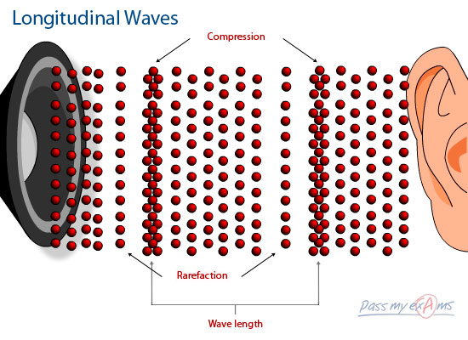
  - Label the wave below:

CKH Take-over: Creative Writing!
Prompt 3: Write about stereotypes: Are there any that you fit? Any times that you’ve been stereotyped, but it’s not true to you? Which is more important?

Prompt 1: Write the story behind your name. You can choose your first or last name, or the story of your family.

Prompt 2: Write about your favorite memory. Go into detail! Who, what, where, when? Why is it so important to you?

