Wave Unit Test Study Guide
Name: __________________________ Core: _____ Date: _____________
Directions: Answer the questions on this sheet to help you prepare for the test. Please remember, though, that this is a guide. Use it to help you get an understanding of the concepts that will be covered, and make sure you review ALL of the vocabulary for this unit. Also, beside each question, I want you to write whether you found it in your “notes” or the “textbook” – if it is the book, write the page number beside the number! Good Luck!
1. A _________________ is any type of disturbance that carries energy.
2. ____________________ is the distance between successive crests or troughs of a wave.
3. What are the two main types of waves? ___________________________________
4. These waves can travel through empty space because they do not require a medium: _____________________
5. In this wave, the motion of the medium is parallel to the motion of the wave. (The energy is being carried by the wave back and forth.) _____________________
6. For this wave, the motion of the medium is perpendicular to the motion of the wave. (The energy and matter move at a 90 degree angle.) ________________
7. As the wavelength of a wave increases, the pitch decreases. TRUE OR FALSE
8. Sound waves travel faster through air than through water. TRUE OR FALSE
9. As the amplitude of a wave increases, the volume decreases. TRUE OR FALSE
10. The primary colors of light are red, blue, and green. TRUE OR FALSE
11. A lens that is thinner in the middle and thicker at the edges is called: ___________________
12. This is the part of the eye that is responsible for detecting an image with its photoreceptive cells: ____________________
13. This is the part of the eye that changes shape to focus the light entering the eye onto the retina: ______________________
14. An object that allows some light to pass through, but makes it hard to clearly see an image through, is called: __________________________
15. If a disturbance occurs in space, does it make a sound? Explain. _________________________ ___________________________________________________________________________________________
16. From light source to your brain, explain the process of you reading this question in at least five steps. ________________________________________________________________________________ ___________________________________________________________________________________________ ___________________________________________________________________________________________
17. Using what you know about light and color, explain why black clothes appear to have a "slimming effect." _________________________________________________________________________ ___________________________________________________________________________________________
18. In the space below, draw and label a transverse wave:

19. In the space below, draw and label a longitudinal wave:

20. What is the difference between a wave that appears blue and a wave that appears red? ___________________________________________________________________________________________
21. Why does the sky appear blue? __________________________________________________________
22. What determines the amount of energy a wave has? _____________________________________
23. What is the only difference between the different waves on the EM Spectrum? ___________________________________________________________________________________________
24. Explain the process that forms a rainbow: ______________________________________________ ___________________________________________________________________________________________
25. Label the diagram of the eye below:
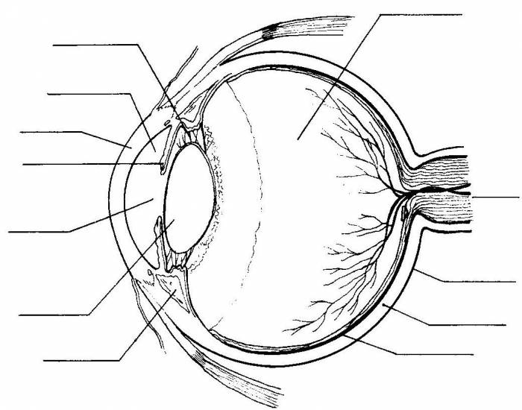

26. Explain, using a diagram if necessary, how a convex lens (like the one in our eye) flips an image: ____________________________________________________________________________________ ___________________________________________________________________________________________
27. If a wave hits a barrier and bounces off of it, we call it: ________________________________
28. If a wave travels between two barriers and then spreads out after passing them, we call it: ______________________________
29. When a wave bends as it changes speed traveling from one medium to another: _____________
30. When waves transfer their energy into the medium and do not bounce back: _______________
31. The color we see is the wavelength that has been: ___________________
32. When waves are able to pass through a medium without interference: ______________________
33. What is the difference between reflection and scattering? ________________________________ _____________________________________________________________________________________________
34. A piece of glass, or even a raindrop, that refracts light is called a: ______________________
35. What is the difference between rods and cones in the eye? _______________________________ ____________________________________________________________________________________________

** Remember to review ALL of the vocabulary words and their definitions!!! **

Part 2:
14. This is the measure of the average molecular motion within an object: _____________________
15. This is the type of heat transfer that occurs through direct contact: ____________________
16. This type of heat transfer provides the majority of our energy on Earth: _____________________
17. A type of material that easily allows the transfer of heat to occur is: ______________________
18. Heat transfer only goes from a warmer object to a cooler one. TRUE OR FALSE
16. Why does heat rise? (Hint: Density!!!) ____________________________________________________ ___________________________________________________________________________________________

