Space Unit: Day 3 Name: ________________________ Core: ____ Date: _Tuesday, May 9th____
2. This causes the seasons on Earth:
A) Tilt of the Axis
B) Revolution
C) Rotation
D) Orbit
3. Humans created this day to make our calendar fit our revolution around the Sun:
A) Labor Day
B) Tilt Day
C) Leap Day

1. This causes night and day on Earth:
A) Rotation
B) Revolution
C) Tilt of the Axis
D) Orbit

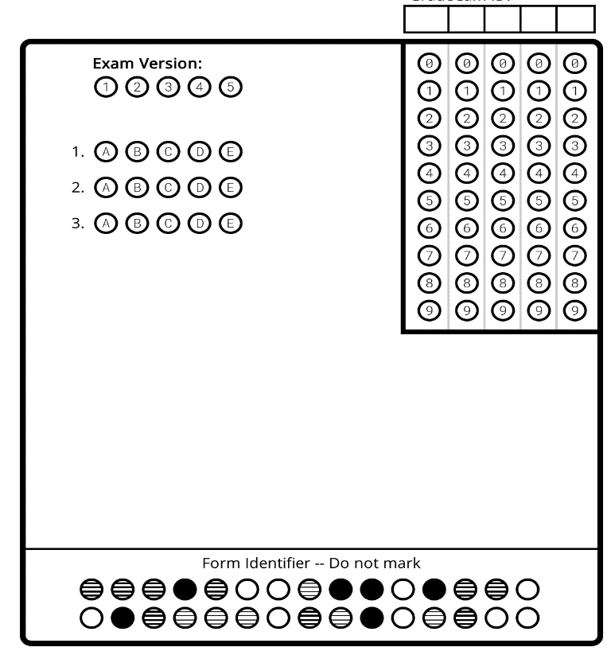

Vocabulary: Based on what you’ve learned, write YOUR OWN definition of each below:
1. Rotation: ____________________________________________________________________________
2. Revolution: __________________________________________________________________________
3. Axis/Tilt: ____________________________________________________________________________
4. Satellite: ____________________________________________________________________________
5. Eclipse: _____________________________________________________________________________
6. Solar Eclipse: ________________________________________________________________________
7. Lunar Eclipse: _______________________________________________________________________
8. Moon Phases: _______________________________________________________________________
Rotation:  - _____________________________________  - _____________________________________  - _____________________________________  - _____________________________________  - _____________________________________  - _____________________________________  - _____________________________________  - _____________________________________  - _____________________________________  - _____________________________________  - _____________________________________ | Revolution:  - _____________________________________  - _____________________________________  - _____________________________________  - _____________________________________  - _____________________________________  - _____________________________________  - _____________________________________  - _____________________________________  - _____________________________________  - _____________________________________  - _____________________________________ | Moon (Phases & Eclipses):  - _____________________________________  - _____________________________________  - _____________________________________  - _____________________________________  - _____________________________________  - _____________________________________  - _____________________________________  - _____________________________________  - _____________________________________  - _____________________________________  - _____________________________________

