Space Unit: Day 1 Name: ________________ Core: _____ Date: _Thursday, May 4th__
1. What is the main purpose of the middle ear?  A) Collect sound waves  B) Amplify Sound Waves  C) Send electrical signals to the brain  D) Interpret the sound | 2. Sound waves travel fastest in:  A) Air (Gas)  B) Iron (Solid)  C) Water (Liquid)  D) A vacuum (Absence of matter) | 3. Which has the greatest effect on the speed of sound?  A) Ability of electrons to travel through a medium  B) The frequency of the wave  C) The amplitude of the wave  D) How close the atoms are in the medium
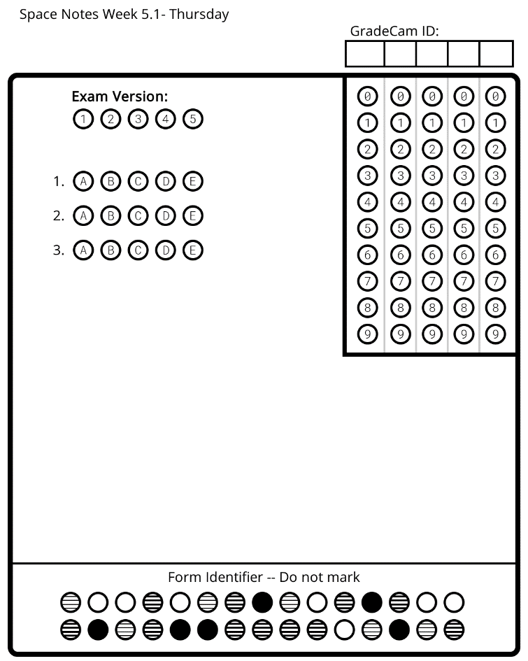
Draw It!

Tilt:

Axis:

Rotation:

Day & Night  - Is the _____________ straight up & down? _________!  - The Earth is tilted on its _____________ _________ degrees.  - How does the Earth move?  - _______________: one complete turn on Earth’s axis.  - As Earth turns, so do _________. You keep the same position with respect to what is _____________ you, but the view above your head changes.  - Earth rotates around an imaginary __________ running through its center called the _____________ ______ _______________. | - The ends of this __________ are the ____________ and ______________ poles.  - What causes day & night?  - As earth rotates on its __________, it turns toward and away from the ___________.  - _______ _______ = your half of the Earth is facing the sun.  - ______ ________= your half of the Earth is turned away from the sun.  - Earth completes one full _________________ every 24 hours!  Time Zones  - As Earth moves, different parts of the Earth receives ______________ at different _________.  - This is why there are different _________ __________ around the world.  - In the US, the ________ ___________ turns toward the sun first.

