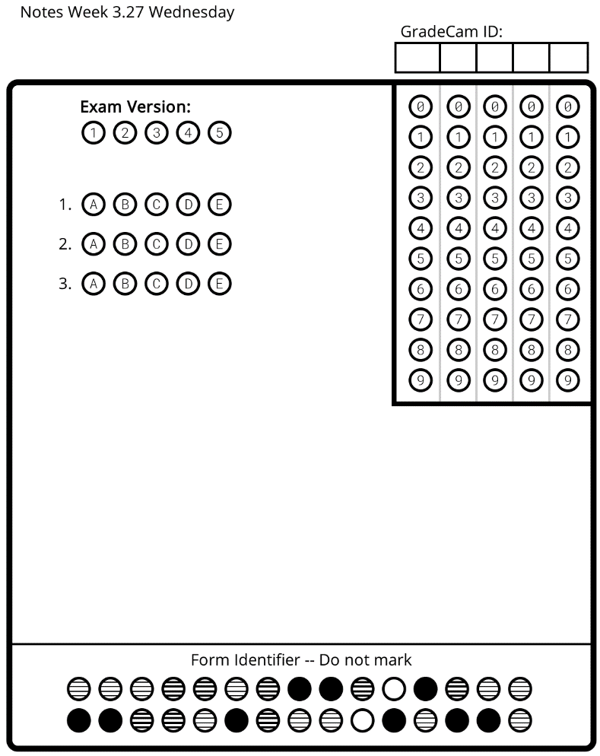
Waves: Day 7 Name: ______________________ Core: _______ Date: Wednesday, March 29th
3. All matter emits this type of radiation:
a) Infra-red
b) Ultra Violet
c) Visible Light
2. This color has the shortest wavelength:
a) red
b) green
c) violet
1. These waves are dangerous to us because they have high energy.
a) UV
b) Longitudinal
c) Infra-red

Vocabulary
1. _______________: the amount of matter packed into a given space, or volume.
2. _______________: these waves, even though can be harmful to skin cells, are used to check for broken bones.
3. _______________: these waves have the smallest wavelength and the most energy.
4. ______________: the distance between crests in a transverse wave, or between compressions of a longitudinal wave.
X-rays * Gamma Rays * Wavelength * Density
- X-rays:
  - X-rays carry a lot of ____________; enough to strip the _________________ from atoms. DNA can be damaged by exposure to ________________ and large doses can even kill cells. You may be able to protect yourself from UV with sun tan cream, but for X-rays you’ll need a sheet of ______________!
  - As a rule the ________________ the material, the more it ________________ X-rays. So if we shine X-rays at a person they pass through the flesh but are _______________ by the bones. If we place a photographic plate on the other side of the person, the bones “cast a ____________” and the shape of the skeleton can be seen.
  - ______________ are used to kill cancer cells. To avoid damaging the healthy tissue around the tumor, ______________ beams are passed through at different ____________, crossing at the tumor, giving it a much _________________ dose.
  - Uses [list at least 2]: _________________________________________________________________
- Gamma Rays
  - Gamma rays have the smallest _________________ (about the size of an ______________’s nucleus!) and the highest ______________. High levels of radiations can only be stopped by many centimeters of _____________, or many meters of _______________.
  - ___________ ___________ can kill living cells, a fact which medicine uses to its advantage, using _____________ __________ to kill cancerous cells.
  - As gamma rays are lethal to all living cells, they can be used to __________________ objects.
  - Controversially, some ______________, especially those that spoil easily, are irradiated with ______________ __________. This process increases the shelf life of the food by killing any fungal spores and bacteria.
  - Uses [list at least 2]: _________________________________________________________________
A: [I need to review.] Watch the BrainPop video “Eyes” and take the quiz. | B. [I’m ready to practice.] Continue working on the Wavestown coloring sheet. | C. [I’m ready for a challenge.] Write a rap or poem that explains the different EM waves and their uses.

