Waves: Day 3 Name: ____________________ Core: _____ Date: Thursday, March 23rd
Quick Check
- How does the matter of a transverse wave travel? A) Side to side B) In circles C) Up & Down
- How does the matter of a longitudinal wave travel? A) Back & Forth B) In circles C) Up & Down
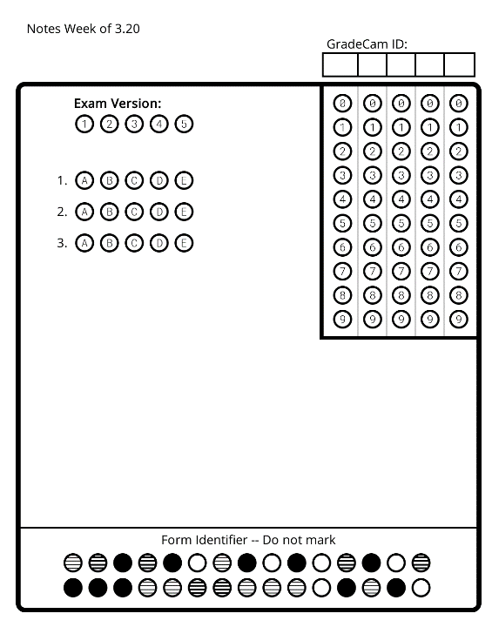
- T/F: Both longitudinal and transverse waves need matter to travel through. A) True B) False
Vocabulary
Amplitude – Crest – Wavelength
Trough – Line of Origin – Frequency

1. The highest part of a transverse wave: _________________
2. The lowest point of a transverse wave: _________________
3. The level of the medium BEFORE the disturbance: __________________
4. The distance from the crest of a transverse wave to the line of origin: ______________
5. The distance between two crests or two troughs of a transverse wave: _____________
6. ______________ the number of cycles a wave completes in a period of time.
E
S
T
O
N
Volume Pitch
- _______________- the volume of a wave (1/2 the height of a wave). As the wave height _______________, the volume ________________.  - For Transverse waves:  - Find the ______________________.  - Use a ruler to measure the distance between the line of origin and either the ________________ or the trough. This distance is called the _________________.  * RULE: the higher the number, the higher the volume. _____________ waves have a higher volume.  - For longitudinal waves:  1. Find a ______________. Use a ruler to measure the distance from the ___________ of the compression to the ________ of it.  *RULE: The larger the distance, the higher the volume. A bigger ____________ makes the wave have a greater volume. | - Frequency- the _________________, high or low (length of a wave). As wavelength ________________, the pitch __________________.  - For transverse waves:  1. Pick two successive ______________ or troughs.  2. Use a ruler to measure the distance between them. This distance is the _________________.  *RULE: the higher the number, the lower the pitch. Waves that are ___________ ___________ have a lower pitch.  - For longitudinal waves:  1. Find two successive ___________________ in the wave.  2. Use a ruler to measure the distance between each one.  *RULE: the larger the distance, the lower the pitch. A wave with _______ __________ compressions has a low pitch.
FUN FACTS: Young people can hear between 20-20,000Hz. * Dogs can hear frequencies that range from 67-45,000Hz. * As you age, your ability to hear high frequencies _________________.* Sounds travels faster in water than in air. Closer ___________ = _______________ movement.
Choose from one of the following activities to complete:
Activity!
A) [I’m a little confused still.] With a partner, get an iPad. Watch the BrainPop video “Waves” and take the quiz. Then, move on to one of the other two activity options if you have time.
B) [I’m ready to practice.] Divide the back of this paper into four quadrants & label them: “High Volume & High Pitch,” “High Volume & Low Pitch,” “Low Volume & High Pitch” and “Low Volume & Low Pitch.” Then get a wave sheet from Ms. George. Cut out and sort the waves into the appropriate quadrant. Check your answers with a partner before you glue anything down!
C) [I’m ready for a challenge.] Pick your favorite appropriate song on YouTube. Listen carefully to the sounds. Pick 5 sounds (voice, drums, etc) and try to draw them on the back of this paper. Think: are they loud or soft? Are they high or low pitch?

