Waves: Day 2 Name: ____________________ Core: _____ Date: Wednesday, March 22nd
Quick Check
- T/F: Mechanical waves can travel through space (a vacuum). A) True B) False
- Sound is an example of which wave? A) EM B) Longitudinal C) Transverse
- The matter a wave travels through: A) Solid B) Gas C) Medium D) Plasma
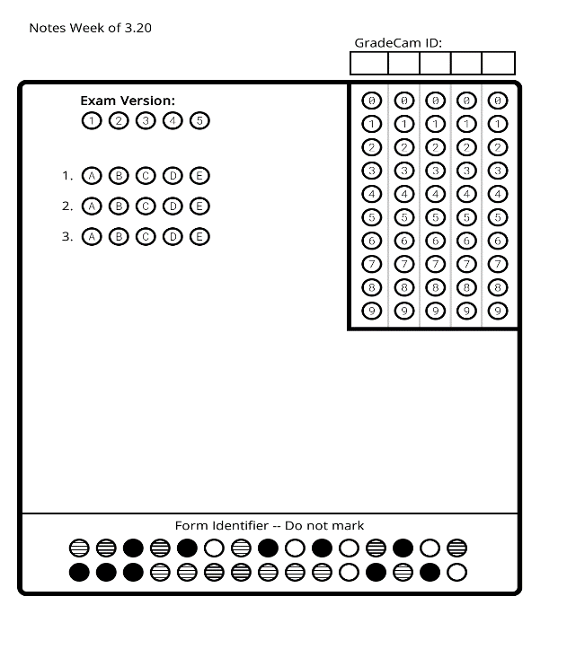
VOCABULARY

Directions: Match each vocabulary word on the left to its definition on the right.
1. ____ crest a) pitch (high or low); length of a wave
2. ____trough b) highest point of a wave
3. ____ wavelength c) distance between crests/troughs
4. ____ amplitude d) volume of a wave (1/2 the wave height)
5. ____ frequency e) when longitudinal waves are close together
6. ____ rarefaction f) lowest point of a wave
7. ____ compression g) when longitudinal waves are far apart

- There are two types of Mechanical Waves: Transverse & Longitudinal
- Longitudinal Waves: The motion of the ____________ is parallel to the motion of the wave.
N
O
T
E
S
  - Example: ______ (seismic) waves are longitudinal.
  - The ________________ of these waves are carried back and forth.
  - The _________________ and _______________ are moving in the same direction.
  - In a longitudinal wave:
    - Compression: When the waves are ________________ _______________
    - Rarefaction: When the waves are ___________ ________________
- Transverse Waves: The motion of the ________________ is perpendicular to the motion of the wave.
  - Example: _____ (seismic) waves are transverse.
  - These waves move ______ and __________.
  - The _______________ and _________________ are not moving in the same direction; they move at a ________ angle.
  - The _______________ is the highest point of a wave and the __________________ is the lowest point.
  - Amplitude is the _______________ of a wave (1/2 the height of a wave). This is measured in __________________.
  - Frequency is the ______________, or high or low of a wave (the length of a wave). This is measured in ___________________.
Draw & Label
Longitudinal
Transverse

Activity: [On the back of this paper] Pick one:
- [I need to review this more.] Watch the DiscoveryEd video: “What Are the Different Types of Waves?” Then create a Venn Diagram to compare and contrast the two different types of waves.
- [I’m ready to practice.] Choose one type of mechanical wave. Cut a piece of string about 6-8 inches long and use it to form the type of wave you chose. Glue it down and label the different parts of your wave.
- [I’m ready for a challenge.] Pick one of the two types of waves and create a word collage picture. Use the vocabulary word to form the picture rather than just drawing the lines. See the example from Ms. George.

