Waves: Day 15 Name: ____________________ Core: _____ Date: _Tuesday, April 25th____
**Today’s Learning Check will be scanned at the END of class and will be taken for a grade.**
1. How many sections do we divide the human ear into?  a. one  b. two  c. three | 2. This part of the ear can be compared to a satellite, because it “funnels” sound into the ear:  a. Pinna  b. Eardrum  c. Ear Canal | 3. These three tiny bones make up the inner ear:  a. Hammer, Anvil, Eardrum  b. Hammer, Anvil, Stirrup  c. Anvil, Eardrum, Stirrup
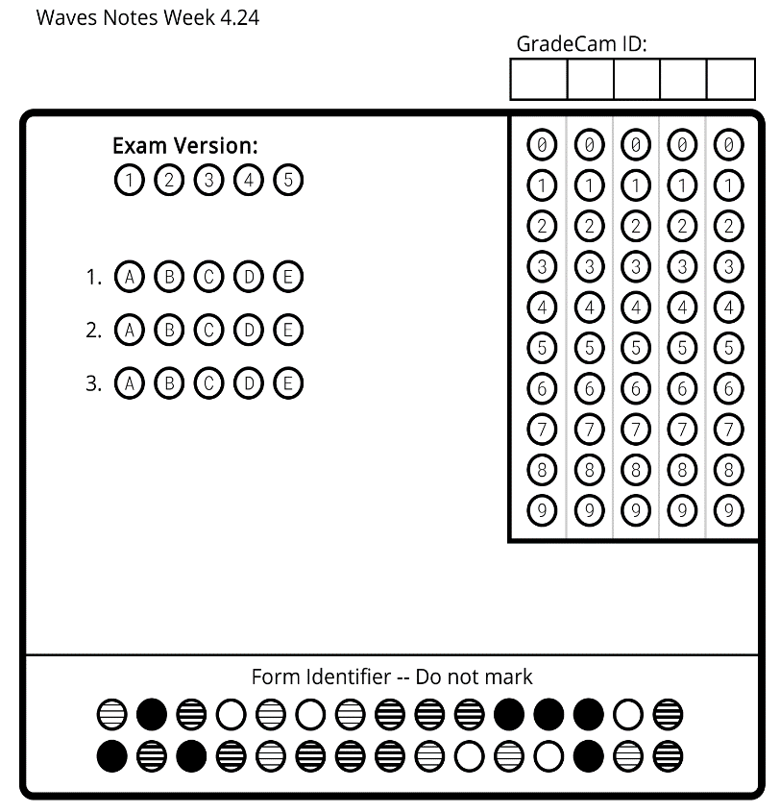
E A R

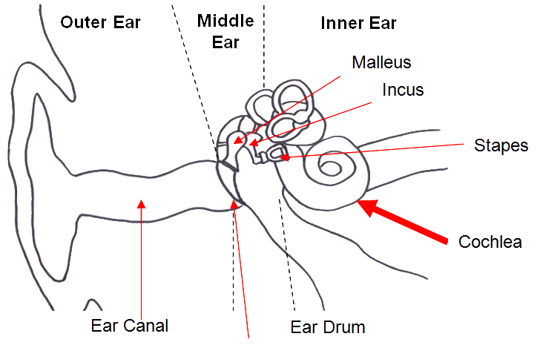

- The human ear: the _________________ humans use to detect sound.
N
O
T
E
S
  - The ear is divided into ________________ sections: the _______________ ear, the __________________ ear, and the ____________________ ear.
  - Each part of the ear serves a specific ____________________ in the task of detecting and interpreting _____________________.
- The outer ear:
  - The outer ear is similar to a ____________________ dish that collects radio waves.
  - The curved formation on the outside (the ________________) helps funnel sound down the _______ ____________ to the eardrum.
- The middle ear:
  - Transfers the energy of a sound wave by vibrating the ___________ ____________ found there.
  - The three bones are the: ________________, ______________, and ______________________.
  - These are the ___________________ bones in your body! Together, they’re about the size of an ___________________ ______________.
- How Sound Travels in the Middle Ear:
  - When _________________ waves reach the middle ear, they cause the eardrum to ______________.
  - This vibration causes the three _________________ to vibrate.
  - These vibrations are transformed into the ____________________/pressure waves in the ________________ ear.
C) [Challenge] Create a flip-book that shows how a sound wave travels through the ear. (This will be finished tomorrow.)
B) [Practice] With a partner, log into DiscoveryEd. Search the interactive video “Human Hearing.”
A) [Review] Watch the BrainPop video, “Hearing.” Then, with your partner, watch the video again and complete the quiz.

