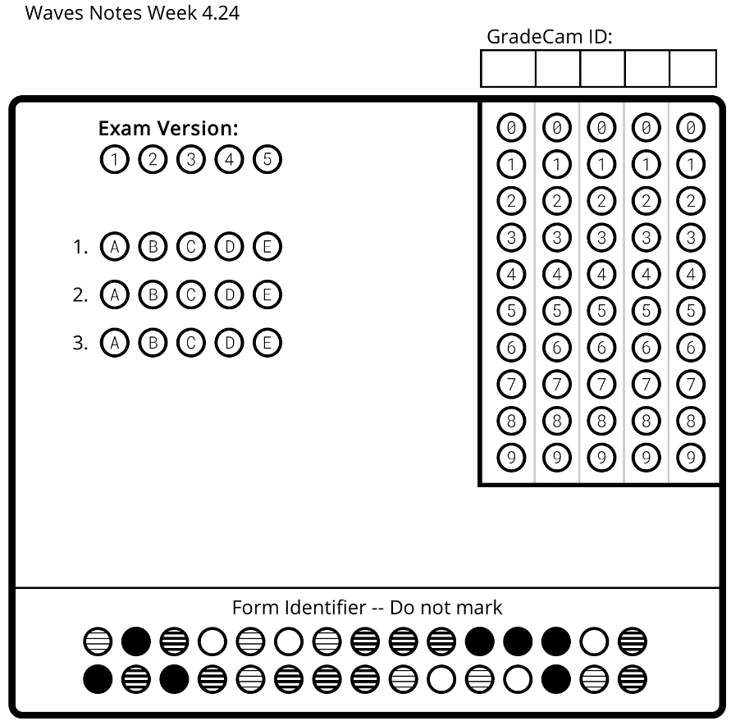
Waves: Day 14 Name: _________________________ Core: _____ Date: __Monday, April 24th _
A) In a longitudinal wave, the length of the compression.
B) The part of a longitudinal wave where the atoms/molecules are far apart.
C) The distance between compressions in a longitudinal wave.
D) The part of a longitudinal wave where the atoms/molecules are really close together.
E) How loud or soft a sound is, determined by the wave amplitude.
F) The high or low sound of a wave, determined by the wavelength.
Vocabulary- Matching
- ___Pitch
- ___Compression
- ___Rarefaction
- ___Wavelength
- ___Volume
- ___Amplitude
NOTES
- __________ is the high or low sound an object makes.
              - Objects that vibrate _________ make a low pitch.
              - Objects that vibrate quickly make a higher pitch.
          - Draw the waves:

          - The wave on the top has a higher ________ than the wave on the bottom because the wave on the top has a shorter _______________, or distance between _____________________.
- ___________ is the loudness or softness of a sound.
- __________ sounds have a lot of ___________.
- __________ sounds use a little _____________.
- Example: The harder a drum is hit, the more the drum will ____________. The more an object vibrates, the _____________ the sound it makes.
- Draw the waves:

- The top wave has a higher _____________, and thus, more volume.
- The bottom wave has a shorter _____________, and thus, less _____________.
How does sound travel?
- Sound waves pass through the ___________ as ____________ waves.
- When the vibrations are _________, you hear a _______ _________.
When they’re slow, you hear a ___________ ____________.
Activities!
A) [Review] Go to DiscoveryEd and log in. Search “Science Lab: Sound” and fill in the guide sheet as you complete the activity.
B) [Practice] Go to DiscoveryEd and log in. Search “Pitch” and click on the exploration titled “Pitch.” Then, search “Volume” and click on the exploration titled “Volume.” Complete BOTH activities and the associated sheet.
C) [Challenge] With a partner, read the “Can Sound Kill You?” article. Then, create a T chart of ways that sound can be either good or bad.

Learning Check:
- The high or low sound of a wave is determined by the wave’s:
  - Amplitude b. Wave Height c. Wavelength d. Medium
- If you measure the size of a wave’s compression, you are measuring:
  - The amount of energy the wave has
  - The amplitude of the wave
  - Both a & b
  - Neither a or b
- Look at the diagram below. In order, what are letters A, B and C pointing to?
B
C

A
  - Compression, Rarefaction, Wavelength
  - Rarefaction, Wavelength, Compression
  - Wavelength, Rarefaction, Compression
  - Wavelength, Compression, Rarefaction

Learning Check:
- The high or low sound of a wave is determined by the wave’s:
  - Amplitude b. Wave Height c. Wavelength d. Medium
- If you measure the size of a wave’s compression, you are measuring:
  - The amount of energy the wave has
  - The amplitude of the wave
  - Both a & b
  - Neither a or b
- Look at the diagram below. In order, what are letters A, B and C pointing to?
B
C

A

  - Compression, Rarefaction, Wavelength
  - Rarefaction, Wavelength, Compression
  - Wavelength, Rarefaction, Compression
  - Wavelength, Compression, Rarefaction

