Waves: Day 1 Name: ____________________ Core: _____ Date: Tuesday, March 21st
1. What are the two main types of waves?  A) Light and Sound B) Mechanical and Transverse  C) Transverse and Longitudinal D) Light and Seismic  2. What is the biggest difference between mechanical and electromagnetic (EM) waves?  A) Only mechanical can travel through space (a vacuum).  B) Only EM waves can travel through space (a vacuum). | 3. This is what we call the matter a wave travels through:  A) medium B) solid C) liquid D) gas  4. Any disturbance that carries energy.  A) a medium B) a seismograph C) a wave D) matter  5. T/F: All waves travel the same way.  A) True B) False
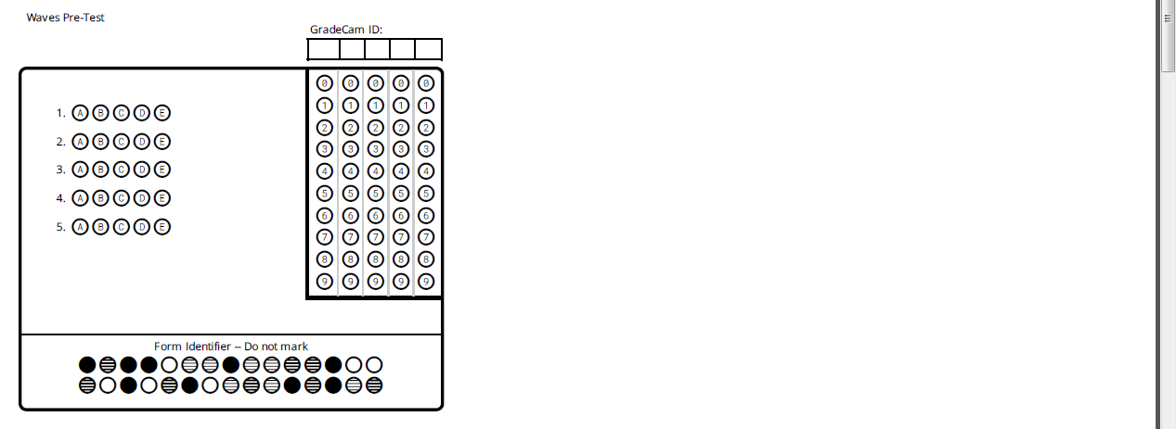
Vocabulary
1. ______________________: waves that can travel through empty space.
2. ______________________: a disturbance that carries energy.
3. ______________________: the matter (solid, liquid, gas) a wave travels through
4. ______________________: waves that must have matter to travel through
5. ______________________: the motion of this wave is parallel to the motion of the medium.
6. ______________________: the motion of this wave is perpendicular to the motion of the medium.

Notes
- Any type of disturbance that carries _____________. It may MOVE ________________ but does not carry it. Waves are created when a __________________ (force) creates a vibration. - - Vibrations in materials set up wavelike disturbances that spread ______________ ________ the source.
- Wave behavior can be described in the following ways: 1) How ______________ the disturbance spreads and 2) __________________: the distance between successive peaks (crests) of the disturbance. Waves move at different ________________ in different materials.
- 2 main types of waves: 1) Electromagnetic: waves that travel through _________ __________. Examples: UV rays, X-Rays, radio waves, visible light. 2) Mechanical: waves that must have _____________ (a medium) to travel through. Examples: sound, ocean waves, seismic waves.
- There are 2 types of mechanical waves: 1) Transverse: these waves move “______ and _________.” Example: ___________________ 2) Longitudinal: These waves travel “____________ and _______________.” Example: ___________________
A little confused? Join me at the whiteboard for a DiscoveryEd review. If not…
On the back of this paper, draw and label a scene with the types of waves that we’ve talked about so far today.
Activity
Stuck? Try some of these illustrations: people, sun, a lake or ocean, a radio
Try to use these labels: sound, light, EM wave, mechanical wave, transverse wave

